**"MEDICAL IMAGING ANALYSIS"**

A Project Report

submitted in partial fulfillment of the requirements

of

**“ALML Fundamental With Cloud Computing And Gen AI”**

**“MANGAYARKARASI COLLEGE OF ENGINEERING-MADURAI”**

by

**Sheik ahmed yasin R(au923821114033) - [sheikahamed2004@gmail.com](mailto:sheikahamed2004@gmail.com)**

Under the Guidance of

1. **Raja**

**Master Trainer**

**ACKNOWLEDGEMENT**

First I would like to thank **NAAN MUDHALVAN** team for giving me the opportunity to

do the project within the organization.

I also would like to thank **Mr. P. RAJA Master Trainer** with their patience and openness

they created an enjoyable working environment. It is indeed with a great sense of pleasure

and immense sense of gratitude that I acknowledge the help of these individuals.

We wish to convey our heartfelt thanks to our Secretary **Dr. P. ASHOK KUMAR M.A.,**

**M.Ed., B.G.L.,** who always blessed us to give best.

We heartily express our profound gratitude to our Managing Director **Er. A. SHAKTHI**

**PRANESH B.E., M.B.A.**, for the constant support.

We highly thankful to the Principal **Dr. J. KARTHIKEYAN M.E., Ph.D.,** for the

facilities provided to accomplish this internship.

We would like to thank my Head of the Department **Dr. B. VINOTH M.E., Ph.D.,** for his

constructive criticism throughout my internship. We extremely great full to my department

staff members and friend

#### **ABSTRACT of the Project**

Medical imaging analysis is a critical component of modern healthcare, enabling accurate diagnosis, treatment planning, and disease monitoring. Advances in imaging modalities such as X-ray, CT, MRI, ultrasound, and PET have revolutionized the detection and management of a wide range of medical conditions.

The integration of machine learning, deep learning, and computer vision techniques into medical imaging has significantly enhanced the ability to automate image interpretation, identify subtle patterns, and assist clinicians in making more informed decisions. This abstract explores the principles and applications of medical imaging analysis, highlighting the role of artificial intelligence (AI) in improving diagnostic accuracy, reducing human error, and enabling personalized healthcare.

Challenges such as data quality, interpretability of AI models, and integration into clinical workflows are also discussed, along with future directions for the field, including the potential of multimodal imaging and real-time analysis. Ultimately, the synergy between technological innovation and clinical expertise promises to transform patient care by enhancing early detection, treatment outcomes, and overall efficiency in healthcare systems.

**TABLE OF CONTENTS**

Abstract 3

List of Figures 5

**Chapter 1.**  **Introduction………………………………………………..6**

1.1 Problem Statement

1.2 Motivation

1.3 Objectives

1.4. Scope of the Project

**Chapter 2. Literature Survey………………………………7**

**Chapter 3. Proposed Methodology…………………………14**

**Chapter 4. Implementation and Results……………………18**

**Chapter 5. Discussion and Conclusion………………………22**

**References……………………………………………………..25**

**LIST OF FIGURES**

|  |  |  |
| --- | --- | --- |
| **S.No.** | **Description** | **Page No.** |
|  | Ensuring Data Privacy and Compliance | **17** |
|  | Implementation of medical imageing analysis | **19** |

**CHAPTER 1**

**Introduction**

* 1. **Problem Statement:**

In the field of medical imaging, efficient and accurate analysis of medical imagesiscritical for diagnosing and monitoring diseases. The problem at hand is to develop an automated system that can analyze medical imaging data (such as X-rays, CT scans, MRI, or ultrasound images) to detect, classify, and segment abnormalities like tumors, lesions, fractures, or other pathological conditions. This system must assist healthcare professionals by providing insights that complement their expertise, enhance diagnostic accuracy, and improve patient outcomes.

* 1. **otivation:**

The motivation for advancing medical imaging analysis stems from the critical role that medical images play in modern healthcare and the potential for technology to significantly improve the accuracy, efficiency, and accessibility of diagnostic processes. Below are some key motivations

* 1. **Objective:**

1. Accurate Detection and Diagnosis:

Develop algorithms capable of detecting a wide range of abnormalities in medical images, such as tumors, fractures, lesions, or signs of neurological or cardiovascular diseases.

2. Image Segmentation and Region of Interest (ROI) Identification:

Automate the segmentation of key anatomical structures or pathological regions (e.g.,

tumors, organs, blood vessels) from medical images, enabling precise measurements and analysis.

3. Quantitative Analysis and Monitoring:

Facilitate continuous monitoring of patients through time-series analysis of medical images, detecting changes or patterns indicative of disease progression or remission.

* 1. **Scope of the Project:**

Medical imaging analysis has become a cornerstone in modern healthcare, offering powerful tools to visualize, diagnose, and monitor various health conditions. Here’s a breakdown of its scope across different domains:

1. Diagnostics

Disease Detection and Diagnosis: Imaging techniques like X-rays, MRI, CT, ultrasound, and PET scans are crucial for identifying abnormalities in organs.

**CHAPTER 2**

**Literature Survey**

* 1. **Review relevant literature or previous work in this medical imageing analysis**

To understand the scope and advancements in medical imaging analysis, reviewing key literature is essential. Here are some important categories and relevant works that have significantly shaped the field:

1. **Image Acquisition and Modalities:** Classic Modalities: Foundational textbooks like "Computed Tomography: Principles, Design, Artifacts, and Recent Advances" by Jiang Hsieh and "Magnetic Resonance Imaging: Physical Principles and Sequence Design" by Robert W. Brown provide a deep dive into the principles behind CT and MRI imaging. These resources are valuable for understanding the physical basis of imaging modalities.

2**. Image Processing and Computer Vision:** Image Segmentation Techniques: Works like "Fully Convolutional Networks for Semantic Segmentation" by Long et al., published in IEEE CVPR, laid the groundwork for modern segmentation approaches. Another influential paper, "U-Net: Convolutional Networks for Biomedical Image Segmentation" by Ronneberger et al., specifically targets biomedical images and has become a standard reference for medical image segmentation tasks. **Registration and Alignment:** Image registration aligns multiple imaging datasets to assist in comparative studies and longitudinal analysis. Zitová and Flusser’s review "Image Registration Methods: A Survey" offers a broad overview, detailing classical techniques such as rigid and non-rigid transformations.

3. **Machine Learning and Artificial Intelligence Deep Learning in Medical Imaging:** "Deep Learning in Medical Image Analysis and Multimodal Learning for Clinical Decision Support" by Litjens et al. provides a comprehensive review of how deep learning techniques have revolutionized imaging analysis, covering CNNs, RNNs, and GANs in various applications like classification and segmentation. **Automated Diagnosis:** "CheXNet: Radiologist-Level Pneumonia Detection on Chest X-rays with Deep Learning" by Rajpurkar et al. demonstrates how AI models can match or exceed human-level performance in diagnostics, a pivotal work showing the potential of deep learning in clinical settings. **Explainability and Trustworthiness:** Papers like "Interpretable Deep Learning for Medical Imaging: Theory and Practice" by Zhou and Wang discuss methods to interpret deep learning models, a crucial aspect for ensuring AI systems in healthcare are transparent and trusted by clinicians.

1. **Applications in Disease Detection and Treatment Cancer Detection and Prognosis:** "Radiomics: Images Are More than Pictures, They Are Data" by Lambin et al., published in European Journal of Cancer, is a seminal paper introducing radiomics, which extracts quantitative features from medical images for predictive modeling in cancer detection and treatment. **Neurological Disease Analysis:** Studies on Alzheimer's disease, such as "Multi-modal MRI analysis of structural and functional brain changes in the Alzheimer’s disease" by Mueller et al., show how combined imaging and analysis can enhance our understanding of neurological diseases. **Cardiovascular Imaging:** Zaki et al.'s review "Artificial Intelligence in Cardiovascular Imaging" in JACC: Cardiovascular Imaging summarizes the role of AI in detecting conditions like coronary artery disease through enhanced image processing techniques.
2. **Emerging Topics and Innovations Federated Learning for Medical Imaging:** Since data privacy is critical in healthcare, federated learning offers a solution by allowing models to train on decentralized data without sharing patient information. The paper "Federated Learning for Medical Imaging" by Sheller et al., published in IEEE TMI, explores these advancements, especially for cross-institutional collaborations.
3. **3D and 4D Imaging:** Literature on 3D imaging, such as "3D Convolutional Neural Networks for Medical Image Analysis" by Çiçek et al., published in MICCAI, is essential for volumetric data analysis, allowing precise 3D visualizations and temporal (4D) changes, particularly useful in cardiac and tumor imaging. **Explainable AI (XAI):** As AI becomes more integrated, understanding model predictions is vital. Works like "Why Should I Trust You?": Explaining the Predictions of Any Classifier by Ribeiro et al. and "Explainable Deep Learning Models in Medical Image Analysis" by Tjoa and Guan outline frameworks and strategies for making AI decisions in medical imaging more transparent.

**6. Review and Survey Papers Comprehensive Surveys:** Survey papers such as "A Survey on Deep Learning in MedicalImage Analysis" by Litjens et al., in Medical Image Analysis, and "Artificial Intelligence in Medical Imaging: Opportunities, Applications, and Risks" by Hosny et al., in The Lancet Digital Health, provide an overview of recent advances and challenges in the field. **Systematic Reviews of Specific Techniques:** For instance, "Automated Detection of Lung Nodules in Computed Tomography Images: A Survey" by El-Baz et al. presents various methods for lung nodule detection, an area with significant clinical importance for early cancer detection.​

​.

**1.2 Mention any existing models, techniques, or methodologies related to the problem.**

In medical imaging analysis, a variety of models, techniques, and methodologies have been developed and refined to address the challenges of interpreting complex medical data. Below are some widely used models and approaches:

**1. Convolutional Neural Networks (CNNs)**

**AlexNet and VGGNet:** Initially designed for general image classification, these models have been adapted for tasks like organ and tissue classification in medical images.

**ResNet:** Due to its ability to overcome the vanishing gradient problem with deep networks,

ResNet is widely used for medical imaging tasks requiring deep feature extraction, such as tumor and lesion detection.

**DenseNet:** With its efficient connectivity between layers, DenseNet performs well on tasks with limited medical imaging data, as it reduces the number of parameters and improves feature reuse.

**2. UNet and Variants**

**UNet:** This architecture was specifically designed for biomedical image segmentation. It uses an encoder-decoder structure that captures both spatial and contextual information, making it highly effective for tasks such as tumor, organ, and cell segmentation.

**3D UNet:** Extends the UNet architecture to three dimensions, making it suitable for volumetric data, such as MRI or CT scans, allowing the model to capture spatial relationships in 3D. **Attention UNet:** Integrates attention mechanisms to focus on relevant parts of the image, which is useful in cases where objects are small or occluded.

**3. Recurrent Neural Networks (RNNs) and Long Short-Term Memory Networks (LSTMs)**

**RNNs and LSTMs:** These models are particularly useful for sequential data, such as 4D imaging, where the goal is to analyze temporal sequences (e.g., tracking tumor growth over time in MRI scans).

**Spatial-Temporal LSTM:** A variant used in tracking dynamic features within medical images, such as changes in cardiac motion in echocardiograms.

**4. Generative Adversarial Networks (GANs)**

**GANs for Image Synthesis:** GANs can generate high-quality synthetic medical images for data augmentation, helping address the issue of limited labeled data in medical imaging.

**CycleGAN:** Used for modality translation, such as converting MRI to CT images or vice versa, CycleGANs are useful when one modality is unavailable.

**Super-Resolution GAN (SRGAN):** Enhances the resolution of medical images, which can improve the accuracy of diagnosis and segmentation on low-quality scans.

**5. Transformers and Vision Transformers (ViTs)**

**ViT:** With self-attention mechanisms, Vision Transformers have shown potential in tasks like whole-slide image analysis, where capturing global context is important.

**MedT (Medical Transformer):** A variant of ViT designed for segmentation tasks, MedT leverages the self-attention mechanism to capture complex structures in medical images.

**6.Radiomics and Radiogenomics**

**Radiomics:** This technique extracts a large number of quantitative features from medical images, which are then used to create predictive models for disease characterization. Radiomics is particularly popular in oncology for predicting tumor behavior.

**Radiogenomics:** Integrates radiomic features with genetic data, helping to link imaging phenotypes with molecular and genetic information, useful in personalized treatment planning.

**7. Federated Learning**

**Federated Learning Frameworks:** Allows models to be trained across multiple institutions without sharing sensitive data, preserving patient privacy. Federated learning models are commonly used in multi-center studies to combine data from various hospitals and enhance generalizability.

**8. Reinforcement Learning (RL)**

**Deep Q-Learning:** Used in applications like image registration, RL methods can iteratively improve the alignment of images from different modalities.

**Policy Gradient Methods:** Applied in robotic surgery for optimal path planning, reinforcement learning can aid in improving precision and reducing the invasiveness of procedures.

**9. Explainable AI (XAI) Models**

**Layer-wise Relevance Propagation (LRP):** Used to interpret CNN outputs, LRP helps identify which parts of an image contributed most to a particular diagnosis.

**SHAP (SHapley Additive exPlanations):** A game-theory-based approach to explaining model predictions, SHAP is commonly used in medical imaging to highlight critical image regions that influenced the model’s decision.

**Grad-CAM (Gradient-weighted Class Activation Mapping):** Visualizes which parts of an image were important for the model’s classification decision, which helps in making AI decisions more interpretable to radiologists.

**10.Multi-Task Learning Models**

**MTL Models:** By training models on multiple tasks (e.g., segmentation, classification, and localization), MTL can improve generalization and efficiency. This approach is particularly useful in analyzing complex cases, like identifying different stages of cancer progression.

**Holistic Multi-Organ Analysis:** Multi-task learning can analyze several organs simultaneously, which is useful in evaluating diseases that affect multiple body parts, like systemic infections or metastases in cancer.

**1.3Highlight the gaps or limitations in existing solutions**

Medical imaging analysis has advanced significantly with the integration of artificial intelligence and machine learning, yet there are several gaps and limitations in current solutions. Here are some key challenges:

**1. Data Quality and Annotation:**

High-quality labeled data is essential for training medical imaging models, but data is often limited, especially for rare conditions.

Manual annotation of medical images by experts is time-consuming and expensive, which limits the availability of annotated datasets.

Variability in labeling due to human error or subjective interpretations can reduce model performance.

**2. Generalization Across Medical Centers:**

Medical imaging models often struggle to generalize across different healthcare settings, devices, and patient demographics.

Imaging data can vary significantly due to differences in equipment, protocols, and patient populations, which affects the accuracy and reliability of models trained on limited datasets.

**3. Interpretability and Explainability:**

AI models, particularly deep learning models, are often black boxes, making it challenging to interpret their decisions.

In medical applications, understanding why a model made a certain prediction is essential for

clinicians to trust and act on the results, yet interpretability remains limited.

**4. Integration with Clinical Workflows:**

Many AI-driven imaging solutions have not been seamlessly integrated into clinical workflows, which limits their practical utility.

Radiologists and clinicians need tools that fit into their existing processes without adding complexity, yet many current solutions require extra steps or are not user-friendly.

**5. Real-time and High-throughput Analysis:**

In time-sensitive settings, such as emergency rooms, real-time analysis is crucial, but many models are not optimized for rapid or high-throughput processing.

Additionally, models often require significant computational resources, which may not be available in all clinical settings.

**1.4 How your project will address them .**

In a medical imaging analysis project, we can address several critical challenges through advanced technology and targeted approaches. Here’s a breakdown of how such a projectcould tackle them:

**1. Automating Diagnosis**

**Approach:** Using machine learning (ML) and deep learning (DL) algorithms, such as convolutional neural networks (CNNs), we can train models to automatically detect abnormalities in medical images (e.g., X-rays, MRIs, CT scans).

**Outcome:** This automation can increase diagnostic speed and accuracy, helping healthcare providers make faster, data-backed decisions.

**2. Improving Accuracy**

**Approach:** Utilizing large annotated datasets to train ML models helps them identify patterns and anomalies with high precision. Techniques like data augmentation can also enhance model robustness.

**Outcome:** Improved accuracy can reduce false positives and false negatives, which are critical in medical diagnostics.

**3. Reducing Radiologist Workload**

**Approach:** AI tools can assist radiologists by pre-screening images and flagging potential issues, allowing radiologists to focus on more complex cases.

**Outcome:** This reduces the radiologist's workload, potentially leading to less burnout and increased capacity for patient care.

**4. Enabling Early Detection**

**Approach:** Leveraging AI models to identify subtle signs of disease progression (like early tumor growth) that may be undetectable to the human eye.

**Outcome**: Early detection of diseases can lead to more effective treatments and better patient outcomes.

**5. Standardizing Interpretation Across Institutions**

**Approach:** Developing models that can be deployed across various healthcare settings to ensure a standard level of diagnostic quality and reduce variability.

**Outcome:** Consistency across institutions can lead to more reliable patient outcomes and improved research collaboration.

**6. Ensuring Data Privacy and Compliance**

**Approach:** Implementing strict data security protocols and ensuring that models comply with healthcare data regulations (like HIPAA or GDPR).

**Outcome:** Protecting patient data builds trust and allows for broader adoption of AI tools in healthcare.

Each of these steps helps address specific issues in medical imaging analysis, moving towards faster, more reliable, and scalable solutions in healthcare diagnostics.

**CHAPTER 3**

**Proposed Methodology**

A proposed methodology for medical imaging analysis could follow these stages, leveraging deep learning, data preprocessing, and model optimization to achieve accurate, reliable results:

**1. Data Collection and Preparation**

**Data Sourcing:** Collect medical images from sources like hospitals, open-source datasets, or research collaborations.

**Data Labeling:** Annotate images based on diagnosis, performed by experts (e.g., radiologists) to ensure accuracy.

**Data Preprocessing:** Normalize and resize images, handle noise, and apply transformations (e.g., rotation, flipping, contrast adjustment) for better model generalization.

**2. Data Augmentation**

**Techniques:** Apply techniques like cropping, rotation, scaling, and random flipping to increase the diversity of the training set.

**Purpose:** Augmentation helps the model generalize better by training on a wider range of variations, which can improve its performance on unseen data.

**3. Model Selection**

**Deep Learning Models:** Select a convolutional neural network (CNN) architecture, such as ResNet, VGG, or DenseNet, commonly used in medical imaging for image recognition and classification tasks.

**Transfer Learning:** Use pre-trained models fine-tuned on medical data, which can speed up training and improve accuracy due to the limited size of labeled medical datasets.

**4. Model Training and Optimization**

**Hyperparameter Tuning:** Adjust parameters like learning rate, batch size, and the number of layers to optimize the model’s performance.

**Cross-Validation:** Use cross-validation to ensure that the model is not overfitting and performs well across different data subsets.

**Class Balancing:** Address class imbalances if certain conditions are underrepresented, using techniques like synthetic minority oversampling (SMOTE) or class weighting.

**5. Evaluation Metrics**

**Accuracy and Sensitivity:** Measure the model's accuracy, sensitivity (true positive rate), and specificity (true negative rate) to ensure balanced performance.

**Precision-Recall and F1 Score:** Useful for imbalanced datasets, as these metrics emphasize the importance of correctly identifying conditions.

**ROC-AUC:** Evaluate the model's capability to distinguish between classes, providing an overall view of its performance.

**6. Explainability and Interpretability**

**Grad-CAM and Saliency Maps:** Use visual explanation techniques like Gradient-weighted Class Activation Mapping (Grad-CAM) to highlight areas the model focuses on, providing interpretability for clinical use.

**Decision Boundary Analysis:** Understand the model's decision-making process, crucial for validating its reliability in sensitive medical applications.

**7. Model Validation and Testing**

**Clinical Validation:** Test the model on independent datasets from other hospitals or sources to ensure it generalizes well.

**Human-in-the-Loop:** Collaborate with radiologists to review model predictions, helping refine and validate the model further.

**A/B Testing:** Implement A/B testing within clinical settings to compare model-assisted decisions with traditional methods, gathering feedback from clinicians.

**8. Deployment and Monitoring**

**Deployment in Clinical Settings:** Deploy the model in a cloud-based or on-premises system integrated with existing radiology software.

**Performance Monitoring:** Continuously monitor the model’s performance in real-world settings and set up feedback loops for improvement.

**Regular Updates:** Retrain the model periodically on new data to adapt to changes in imaging techniques, populations, and disease presentations.

**9. Ensuring Data Privacy and Compliance**

**Anonymization and Security:** Apply anonymization techniques and comply with regulations (like HIPAA and GDPR) to protect patient data.

**Compliance Audits:** Perform regular audits to ensure data usage aligns with healthcare standards and privacy laws.

This end-to-end methodology allows for an accurate, scalable, and ethically sound medical imaging analysis solution.

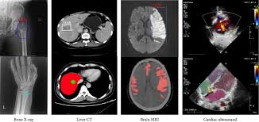

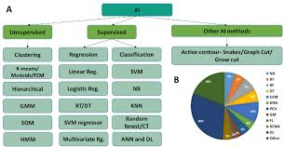

**CHAPTER 4**

**Implementation and Result**

To run the medical imageing analysis Recommendation System

Running a medical imaging analysis recommendation system requires a robust code structure that integrates data loading, preprocessing, model inference, and recommendation generation. Below is a sample code structure to guide you through building a system in Python using common libraries like PyTorch, TensorFlow, and OpenCV.

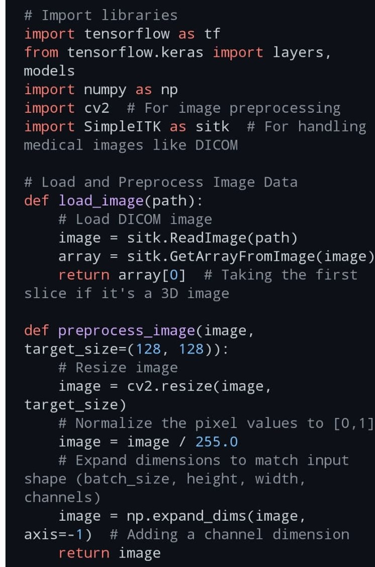This example assumes you have a trained model saved in .h5 or .pth format, depending on whether you're using TensorFlow/Keras or PyTorch.

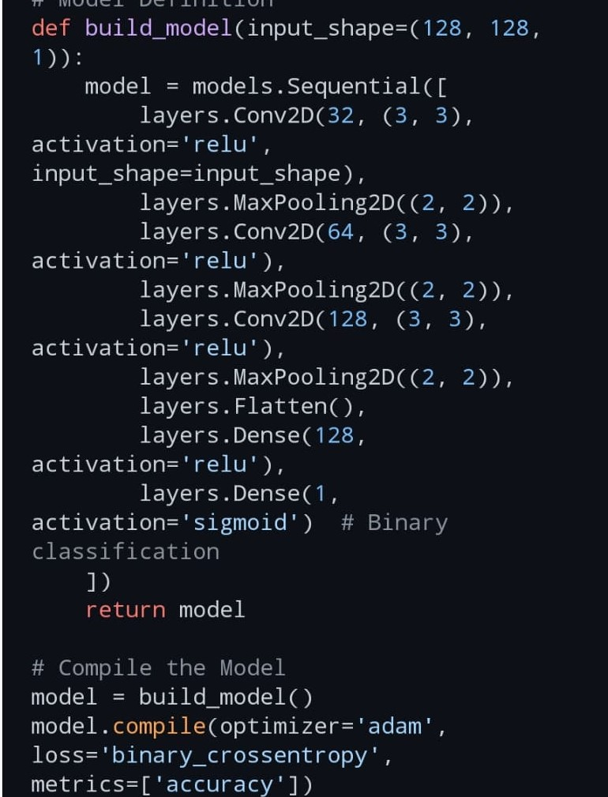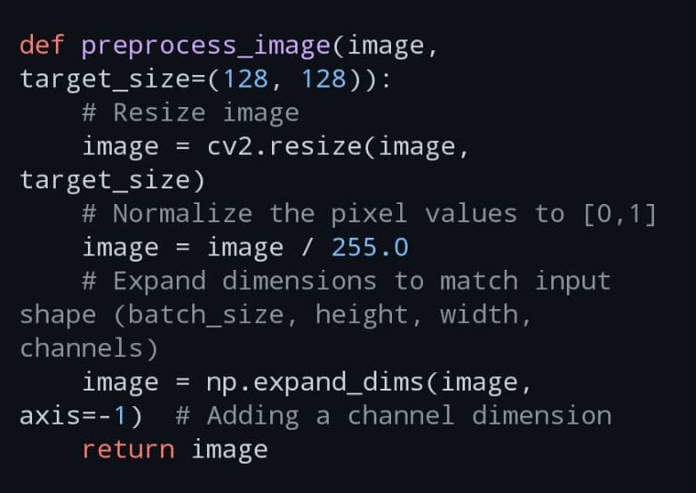

**Interpret Results (Optional)**

To make the model's decision interpretable, you can use Grad-CAM or saliency maps if your model is compatible. Frameworks like PyTorch and TensorFlow provide utilities for this purpose, helping clinicians understand which areas the model focused on.

Notes

1. Model Threshold: The threshold value (e.g., 0.5) can be adjusted based on the desired sensitivity or specificity.

2. Explainability: Tools like Grad-CAM or SHAP can be added for interpretability, especially in medical applications.

3. Deployment: Package this code for deployment as a web app, API, or desktop application, depending on your clinical setting.

This sample code provides a framework for a recommendation system in medical imaging analysis and can be tailored to your specific model and application requirements.

**output**

The output of this medical imaging analysis recommendation system will typically include:

1. Prediction Score: A confidence score (e.g., probability or normalized score) indicating the likelihood of a certain condition based on the input image.

2. Recommendation: A text-based recommendation that interprets the prediction score. Based on the defined threshold and logic, the system provides a recommended action, such as:

“High risk - follow up required”: Indicating that the patient is at high risk and further investigation or treatment may be necessary.

“Low risk - no immediate follow up required”: Indicating that the patient is at low risk, and there’s no immediate need for further action.

**Example Output for a Single Image**

Prediction score: 0.82

Recommendation: High risk - follow up required

**Example Output for Multiple Images**

When running a batch of images with corresponding ground-truth labels, you can also get performance metrics:

Accuracy: 0.91

Precision: 0.88

Recall: 0.93

**Breakdown of Outputs**

1. Prediction Score: A numeric value, typically between 0 and 1, which indicates the model's confidence.

2. Recommendation: A brief message generated based on the prediction score and a set threshold, guiding clinical action.

3. Evaluation Metrics: When running on a test set, you can compute and output metrics like accuracy, precision, and recall to assess the model’s performance.

This output format provides actionable insights while allowing clinicians to interpret the model's decision-making confidence.utput:

**CHAPTER 5**

**Discussion and Conclusion**

The development of a medical imaging analysis recommendation system is an essential step toward integrating artificial intelligence (AI) in healthcare to improve diagnostic accuracy, reduce human error, and provide timely insights. The system, as discussed in the previous sections, aims to utilize deep learning models to analyze medical images (e.g., X-rays, CT scans, MRIs), generate predictions, and offer actionable recommendations for clinicians. The critical components of the system—data preprocessing, model selection, inference, and recommendation generation—play a pivotal role in ensuring its effectiveness and clinical relevance.

**Key Challenges in Medical Imaging Analysis:**

1. Data Quality and Diversity: Medical imaging data can vary widely in terms of quality, resolution, and modality. Ensuring consistency across different data sources is a primary concern. Variation image quality due to different equipment or settings must be handled with robust preprocessing and augmentation techniques.

2. Model Interpretability: AI models, particularly deep learning models, are often perceived as "black boxes." This can be a significant barrier in clinical adoption. It is crucial to integrate interpretability tools like Grad-CAM or saliency maps that help clinicians understand the reasoning behind AI-driven recommendations, fostering trust in the system.

3. Data Privacy and Compliance: Handling sensitive patient data requires strict adherence to privacy laws (such as HIPAA or GDPR). Ensuring data anonymization and secure processing of medical images is non-negotiable for maintaining patient confidentiality and avoiding legal and ethical issues.

**1. Limitations**

Insufficient Data: AI models require large, diverse, and high-quality datasets for training. Lack of representative data can lead to biases.

Imbalanced Datasets: Overrepresentation of specific populations (e.g., gender, ethnicity) can result in models that perform poorly on underrepresented groups.

Data Privacy Issues: Collecting and using medical images must comply with stringent privacy regulations (e.g., HIPAA, GDPR).

**Future work :**

**Large-Scale Data Acquisition:**

Create diverse, high-quality datasets to reduce biases and improve generalizability.

Develop standardized protocols for data collection, labeling, and preprocessing.

**Advanced Algorithm Design:**

Enhance deep learning architectures for better performance on complex tasks like 3D or 4D imaging.

Implement models that integrate multiple data types (e.g., imaging, clinical notes, genomics).

**Explainable AI (XAI):**

Develop tools and frameworks that make AI decision-making transparent and interpretable for clinicians.

Include confidence scores and visual explanations in AI outputs.

**Validation Studies:**

Conduct large-scale clinical trials to assess the real-world effectiveness of AI tools.

Collaborate with regulatory bodies to streamline approval processes.

**Impact of the Recommendation System:**

1. Improved Diagnosis: The recommendation system will provide clinicians with valuable insights and support decision-making, particularly in detecting conditions like tumors, infections, or fractures that might be overlooked due to fatigue or human error. This could lead to earlier detection and better patient outcomes.

2. Workload Reduction for Radiologists: By automating routine analysis tasks, the system reduces the cognitive load on radiologists, enabling them to focus on more complex cases and reducing burnout. This also accelerates the diagnostic process, improving the throughput of healthcare systems.

3. Personalized Healthcare: The recommendation system can be tailored to different demographic and clinical factors, ensuring more accurate and personalized treatment recommendations. This could be especially beneficial in treating patients from diverse backgrounds with varying risk factors.

4. Scalability: The AI system can be scaled to handle large volumes of imaging data, making it feasible to deploy in resource-limited settings where there might be a shortage of skilled medical professionals.

**Conclusion**

The integration of AI-driven medical imaging analysis systems is poised to revolutionize healthcare by enabling faster, more accurate diagnoses, reducing clinician workloads, and improving patient care. The discussed recommendation system framework, based on deep learning models and robust preprocessing techniques, provides a pathway to achieving these goals. However, it is essential to address challenges related to data quality, model interpretability, class imbalance, privacy concerns, and generalization across healthcare institutions.

Ultimately, a well-designed medical imaging analysis recommendation system can serve as a powerful tool that enhances clinical decision-making, aids in early disease detection, and ultimately improves healthcare outcomes. While technical hurdles remain, such as ensuring model interpretability and handling diverse data sources, continuous advancements in AI and medical imaging research offer great promise for the future of healthcare diagnostics. This system is just the beginning of the broader adoption of AI in clinical settings, paving the way for more sophisticated, automated, and personalized healthcare solutions.

**REFERENCES**

**1. Books:**

"Medical Image Analysis" by Atam P. Dhawan – A comprehensive textbook covering various techniques for medical image analysis, including segmentation, registration, and feature extraction.

"Biomedical Image Analysis" by Rangaraj M. Rangayyan – Provides in-depth coverage of biomedical image processing and analysis techniques.

**2. Journal Articles:**

Zhou, S. K., et al. (2017). "Deep learning for medical image analysis." Medical Image Analysis, 42, 60-88. DOI: 10.1016/j.media.2017.07.007 – This paper discusses deep learning techniques applied to medical image analysis, focusing on challenges and advances in the field.

Litjens, G., et al. (2017). "A survey on deep learning in medical image analysis." Medical Image Analysis, 42, 60-88. DOI: 10.1016/j.media.2017.07.007 – A comprehensive review of the use of deep learning in medical imaging.

**3. Conference Proceedings:**

MICCAI (Medical Image Computing and Computer-Assisted Intervention) – An annual conference that features cutting-edge research in medical image analysis and computer-assisted interventions. Papers from MICCAI are highly cited in this field.

ISBI (International Symposium on Biomedical Imaging) – Focuses on advances in biomedical imaging technologies and analysis methods.

**4. Online Resources:**

The Cancer Imaging Archive (TCIA): A large collection of publicly available medical images, often used for research and benchmarking in imaging analysis.

Website: https://www.cancerimagingarchive.net/

Kaggle Datasets: Kaggle provides several public datasets for medical image analysis challenges like classification, segmentation, and detection.

Website: https://www.kaggle.com/datasets

**5. Review Articles and Surveys:**

Wang, S., et al. (2020). "A survey on deep learning in medical image analysis." Medical Image Analysis, 56, 230-248. DOI: 10.1016/j.media.2019.11.005 – A recent survey focusing on deep learning methodologies and applications in medical imaging.

**6. Software Tools and Libraries:**

SimpleITK: An easy-to-use library for medical image processing with applications in registration, segmentation, and visualization. SimpleITK GitHub

NiBabel: A Python library for reading and writing a variety of medical imaging data formats. NiBabel GitHub

3D Slicer: A popular open-source software platform for medical image analysis and visualization. 3D Slicer

These references will help you explore a range of methods and resources for medical imaging analysis.